Practical - 12

Practical Title: Event Management CRUD with Poster Upload and File Validation

Develop event management functionality for admin users. Admin can add, view, update, delete, and upload event posters with file type and file size validation.

Theory:
- Are add, update, and delete functionalities implemented correctly?
Yes, the add, update, and delete functionalities are implemented to manage event records in the database
- Is the UI linked with the database correctly?
Yes, the user interface is connected to the MySQL database using PHP, allowing event records to be displayed and managed.
- Are poster uploads validated for type and size?
Poster upload validation should check the file type and size before uploading. If these checks are implemented in the code, invalid files are rejected.
- Are success and failure messages displayed?
Yes, success and failure messages can be displayed to inform users whether an operation was completed successfully or an error occurred.

Implementation
Important PHP functions and features

Function / Feature Purpose
session_start() Starts or resumes a session.
isset() Checks whether a variable or value exists.
mysqli() Connects PHP to the MySQL database.
prepare() Prepares an SQL statement.
bind_param() Binds values to a prepared SQL statement. execute() Executes the SQL statement.
move_uploaded_file() Saves an uploaded poster to the upload folder.

Evidence of Work (Screenshots)
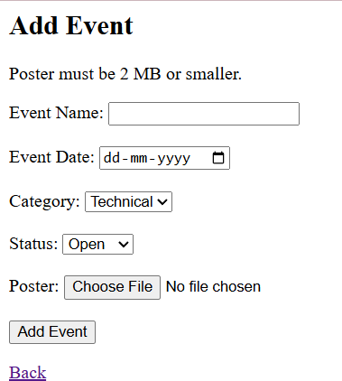

GitHub Repository Link: https://github.com/shahmahi0717/Student-Hub-Portal

Challenges Faced:

Implementing add, view, update, and delete operations for event records.

Validating poster images based on file type and file size.

Learning Outcomes:

- Learned how to perform CRUD operations on event records.

Faculty Remarks: (Keep this blank for faculty)



